**How To Install & Run ConvergedConfereceApp**

Converged Conference Application is built with two separate applications (war files) which work together:

* ConvergedConferenceApp.war is responsible for Web User Interface implementation
* Dlgmsc_conf.war file is responsible for the business logic side of the application as well as Dialogic XMS Media Server connectivity using JSR 309 connector.

Therefore application distribution comes with two war files as well as following properties files (Get it under PropertyFiles folder):

* ConvergedConferenceApp.war
* dlgmsc_conf.war
* dlgc_demos.properties
* conf_room.json

The following MediaFiles (located under Media directory) needs to be added to /var/lib/xms/media/en-US/ XMS directory.

* conf_greeting.wav
* invalid_id_beep.wav
* jointoconf.wav
* server_busy_bye.wav
* beep.wav

To install the application:

* Place two war files in $CATALINA_HOME/webapps directory
* And place both properties files into $CATALINA_HOME/conf/Dialogic (Dialogic directory will need to be created).

Note: $CATALINA_HOME/ 🡪 /home/apachetomcat8(your user account)/mss-XXXXX-apache-tomcat-XX

Next, the TeleStax AS can be started. Before the SIP part of convergent application can work appropriate Application Routing needs to be established. With TeleStax AS up and running go to:

http://<TeleStaxAS-IP-Address>:8080 which will bring up TeleStax AS configuration page:

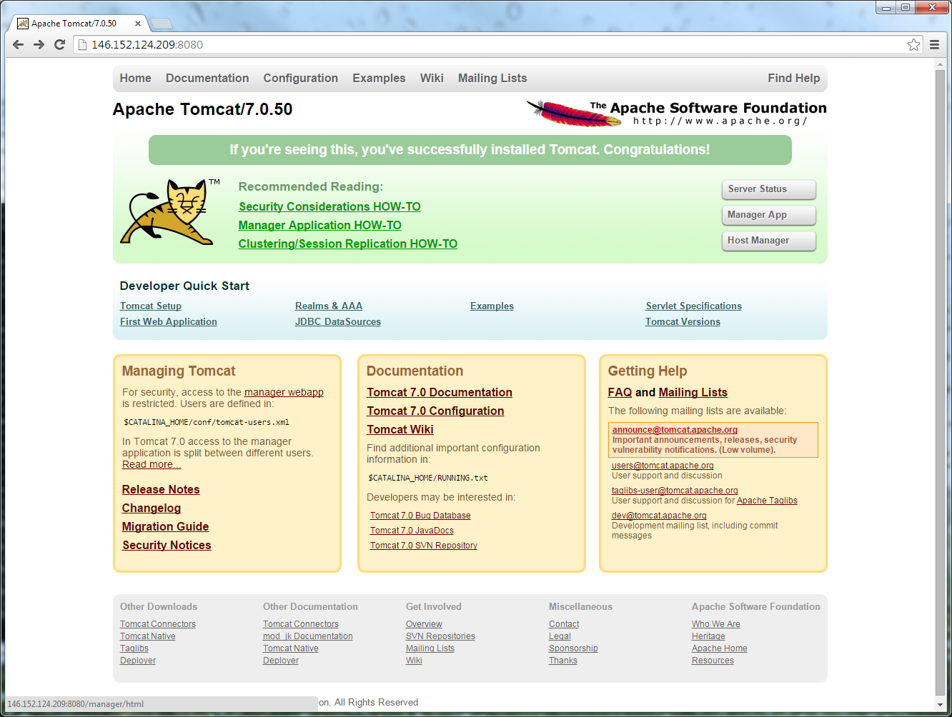 Click on “Manager App” button:

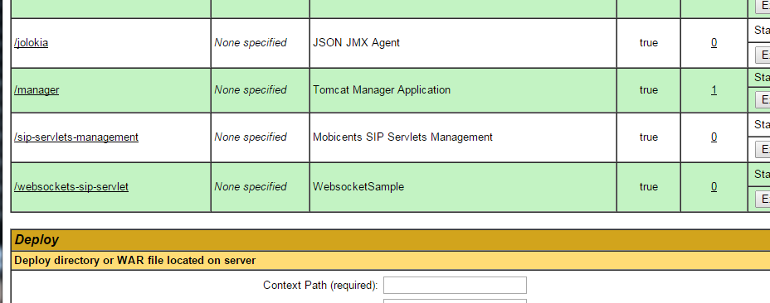

Scroll down and click on “sip-servlets-management”:

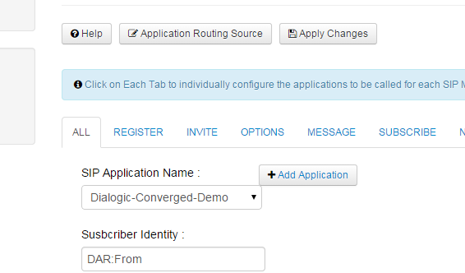

For every tab (ALL, REGISTER, INVITE, OPTIONS) select “SIP Application Name:” to be “Dialogic-Converged-Demo”. Click “Apply Changes” for the changes to take effect and you are done!

**SSL Certificate on Tomcat**:

Follow these instructions:

<http://jmchung.github.io/blog/2013/09/06/centos-installing-apache-portable-runtime-apr-for-tomcat/>

**IMPORTANT NOTE**:Make a use of –prefix=/home/tomcat8/apr option when executing ./configure

For Example:

./configure -prefix=/home/apachetomcat8/apr

./configure -prefix=/home/apachetomcat8/apr -prefix=/home/apachetomcat8/apr

./configure --with-apr=/home/apachetomcat8/apr -prefix=/home/apachetomcat8/apr

./configure --with-apr=/home/apachetomcat8/apr --with-java-home=/usr/java/jdk1.8.0_92/ -prefix=/home/apachetomcat8/apr

Edit server.xml under $CATALINA_HOME/conf to set “SSLCertificateFile” and “SSLCertificateKeyFile”:

      <Connector

        protocol="org.apache.coyote.http11.Http11AprProtocol"

        port="8443" maxThreads="200"

        scheme="https" secure="true" SSLEnabled="true"

        SSLCertificateFile="/opt/xms.crt" -> /home/apachetomcat8/server.crt

        SSLCertificateKeyFile="/opt/xms.key" -> /home/apachetomcat8/server.key

        sslProtocol="TLSv1+TLSv1.1+TLSv1.2"

        />

Here is how to generate SSL certificates: <http://blog.justin.kelly.org.au/how-to-create-a-self-sign-ssl-cert-with-no-pa/>

**Accessing the demo:**

1. Accessing Converged Conference Application via web browser:

http://<TeleStaxAS-IP-Address>:8080/ConvergedConferenceApp

or

https://<TeleStaxAS-IP-Address>:8443/ConvergedConferenceApp

Note:

1. Application name (ConvergedConferenceApp) is the name used during creation of the war file as described in “Getting started with Web UI part of the ConvergedConfereceApp Project in Eclipse” document in chapter 6) Building the WAR file.
2. https configuration requires TeleStax AS to be configured for SSL. NOTE: https is required for screen share feature is to be used.
3. Accessing Converged Conference Application using SIP client:

DlgcConvergedConferenceDemo=<ConferenceID>@<TeleStaxAS-IP-Address>:5080